Assignment 1
Name : Ujwal Tikhe
Class : BE Comp B
Roll No. : 135

Aim : Write a program non-recursive and recursive program to calculate Fibonacci
numbers and analyze their time and space complexity.

Code :
def fibonacci_iterative(n:int):
if n == 1:
return 0
elif n == 2:
return 1
else:
dp = [0] * n
dp[0] = 0
dp[1] = 1
for i in range(2,n):
dp[i] = dp[i-1] + dp[i-2]
return dp[n-1]

def fibonacci_recursive(n):
cache = {
1:0,
2:1
}
return helper(n,cache)

def helper(n:int,cache):
if n in cache:
return cache[n]
else:
return helper(n-1,cache) + helper(n-2,cache)

n = int(input("Enter value of n(nth Fibonacci number): "))
print(f"Fibonacci Number(Iterative): {fibonacci_iterative(n)}")
print(f"Fibonacci Number(Recursive): {fibonacci_recursive(n)}")

OUTPUT :

Assignment 2
Name : Ujwal Tikhe
Class : BE Comp B
Roll No. : 135

Aim : Write a program to implement Huffman Encoding using a greedy strategy.

Code :

class Node:
def __init__(self,left=None,right=None,value=None,frequency=None):
self.left = left
self.right = right
self.value = value
self.frequency = frequency

def children(self):
return (self.left,self.right)

class Huffman_Encoding:
def __init__(self,string):
self.q = []
self.string = string
self.encoding = {}

def char_frequency(self):
count = {}
for char in self.string:
if char not in count:
count[char] = 0
count[char] += 1

for char,value in count.items():
node = Node(value=char,frequency=value)
self.q.append(node)
self.q.sort(key=lambda x: x.frequency)

def build_tree(self):
while len(self.q) > 1:
n1 = self.q.pop(0)
n2 = self.q.pop(0)
node = Node(left=n1,right=n2,frequency=n1.frequency + n2.frequency)
self.q.append(node)
self.q.sort(key = lambda x:x.frequency)

def helper(self,node:Node,binary_str="",):
if type(node.value) is str:
self.encoding[node.value] = binary_str
return
l,r = node.children()
self.helper(node.left,binary_str + "0")
self.helper(node.right,binary_str + "1")
print(node.frequency)
return

def huffman_encoding(self):
root = self.q[0]
self.helper(root,"")

def print_encoding(self):
print(' Char | Huffman code ')
for char,binary in self.encoding.items():
print(" %-4r |%12s" % (char,binary))

def encode(self):
self.char_frequency()
self.build_tree()
self.huffman_encoding()
self.print_encoding()

string = input("Enter string to be encoded: ")
# string = 'AAAAAAABBCCCCCCDDDEEEEEEEEE'
encode = Huffman_Encoding(string)
encode.encode()

# The time complexity for encoding each unique character based on its frequency is O(nlog n).

# Extracting minimum frequency from the priority queue takes place 2*(n-1) times and its complexity is O(log n). Thus the overall complexity is O(nlog n).

OUTPUT :
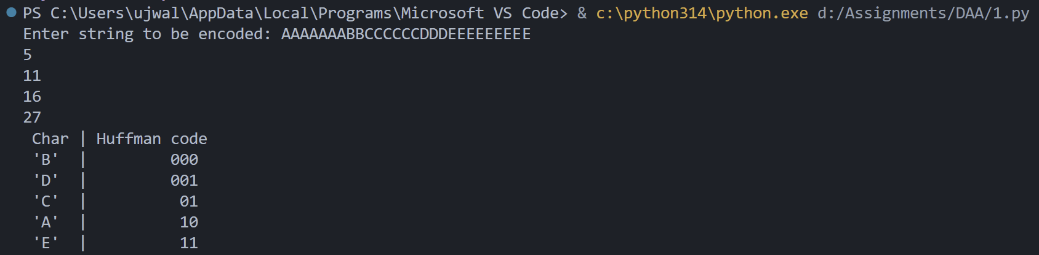

Assignment 3
Name : Ujwal Tikhe
Class : BE Comp B
Roll No. : 135

Aim : Write a program to solve a fractional Knapsack problem using a greedy method.

Code :
def fractional_knapsack(values, weights, capacity):
items = []

for i in range(len(values)):
ratio = values[i] / weights[i]
items.append((ratio, values[i], weights[i]))

# Sort by value/weight ratio in descending order
items.sort(reverse=True)

total_value = 0

for ratio, value, weight in items:
if capacity >= weight:
capacity -= weight
total_value += value
else:
total_value += ratio * capacity
break

return total_value

n = int(input("Enter number of items: "))

values = list(map(int, input("Enter values of items: ").split()))
weights = list(map(int, input("Enter weights of items: ").split()))

capacity = int(input("Enter maximum weight: "))

maximum_value = fractional_knapsack(values, weights, capacity)

print("The maximum value of items that can be carried:", maximum_value)

OUTPUT :
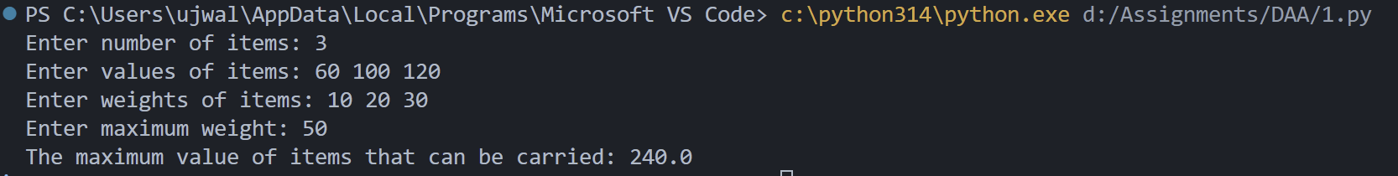

Assignment 4
Name : Ujwal Tikhe
Class : BE Comp B
Roll No. : 135

Aim : Write a program to solve a 0-1 Knapsack problem using dynamic programming or
branch and bound strategy.

Code :
def knapsack(values, weights, capacity):
n = len(values)

dp = [[0 for _ in range(capacity + 1)]
for _ in range(n + 1)]

for i in range(1, n + 1):
for w in range(1, capacity + 1):

if weights[i - 1] <= w:
dp[i][w] = max(
values[i - 1] + dp[i - 1][w - weights[i - 1]],
dp[i - 1][w]
)
else:
dp[i][w] = dp[i - 1][w]

return dp[n][capacity]

n = int(input("Enter number of items: "))

values = list(map(int, input("Enter values of items: ").split()))
weights = list(map(int, input("Enter weights of items: ").split()))

capacity = int(input("Enter maximum weight: "))

maximum_value = knapsack(values, weights, capacity)

print("The maximum value of items that can be carried:", maximum_value)

OUTPUT :
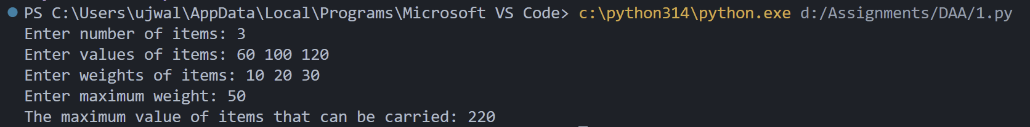
Assignment 5
Name : Ujwal Tikhe
Class : BE Comp B
Roll No. : 135

Aim : Design n-Queens matrix having first Queen placed. Use backtracking to place remaining Queens to generate the final n-queen‘s matrix.

Code :

class NQueens:

def __init__(self):
self.size = int(input("Enter size of chessboard: "))
self.board = [[False] * self.size for _ in range(self.size)]
self.count = 0

def printBoard(self):
for row in self.board:
for ele in row:
print("Q" if ele else "X", end=" ")
print()
print()

def isSafe(self, row, col):
# Check column
for i in range(self.size):
if self.board[i][col]:
return False

# Check upper-left diagonal
i, j = row - 1, col - 1
while i >= 0 and j >= 0:
if self.board[i][j]:
return False
i -= 1
j -= 1

# Check upper-right diagonal
i, j = row - 1, col + 1
while i >= 0 and j < self.size:
if self.board[i][j]:
return False
i -= 1
j += 1

return True

def set_position_first_queen(self):
print("Enter coordinates of first queen:")

row = int(input(f"Enter row (1-{self.size}): "))
col = int(input(f"Enter column (1-{self.size}): "))

if not (1 <= row <= self.size and 1 <= col <= self.size):
print("Invalid position.")
return False

self.board[row - 1][col - 1] = True
self.printBoard()
return True

def solve(self, row):
if row == self.size:
self.count += 1
self.printBoard()
return

# Skip the row containing the initially placed queen
if any(self.board[row]):
self.solve(row + 1)
return

for col in range(self.size):
if self.isSafe(row, col):
self.board[row][col] = True
self.solve(row + 1)
self.board[row][col] = False

def displayMessage(self):
if self.count > 0:
print("Solution exists for the given position of the queen.")
else:
print("Solution doesn't exist for the given position of the queen.")

solver = NQueens()

if solver.set_position_first_queen():
solver.solve(0)
solver.displayMessage()

OUTPUT :
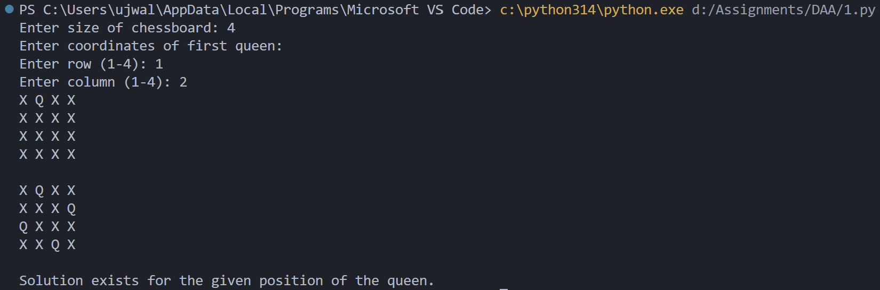

BT Assignment

Assignment 3
Name : Ujwal Tikhe
Class : BE Comp B
Roll No. : 135

Aim : Write a smart contract on a test network,
for Bank account of a customer for
following operations:
•Deposit money
• Withdraw Money
• Show balance

Code:

pragma solidity >=0.6.2 <0.9.0;

contract SimpleBank {
uint8 private clientCount;
mapping (address => uint) private balances;
address public owner;

// Log the event about a deposit being made by an address and its amount
event LogDepositMade(address indexed accountAddress, uint amount);

// Constructor is "payable" so it can receive the initial funding of 30,
// required to reward the first 3 clients
constructor() public payable {
require(msg.value == 30 ether, "30 ether initial funding required");
/* Set the owner to the creator of this contract */
owner = msg.sender;
clientCount = 0;
}

/// @notice Enroll a customer with the bank,
/// giving the first 3 of them 10 ether as reward
/// @return The balance of the user after enrolling
function enroll() public returns (uint) {
if (clientCount < 3) {
clientCount++;
balances[msg.sender] = 10 ether;
}
return balances[msg.sender];
}

/// @notice Deposit ether into bank, requires method is "payable"
/// @return The balance of the user after the deposit is made
function deposit() public payable returns (uint) {
balances[msg.sender] += msg.value;
emit LogDepositMade(msg.sender, msg.value);
return balances[msg.sender];
}

/// @notice Withdraw ether from bank
/// @return remainingBal The balance remaining for the user
function withdraw(uint withdrawAmount) public returns (uint remainingBal) {
// Check enough balance available, otherwise just return balance
if (withdrawAmount <= balances[msg.sender]) {
balances[msg.sender] -= withdrawAmount;
payable(msg.sender).transfer(withdrawAmount);
}
return balances[msg.sender];
}

/// @notice Just reads balance of the account requesting, so "constant"
/// @return The balance of the user
function balance() public view returns (uint) {
return balances[msg.sender];
}

/// @return The balance of the Simple Bank contract
function depositsBalance() public view returns (uint) {
return address(this).balance;
}
}

Assignment 4
Name : Ujwal Tikhe
Class : BE Comp B
Roll No. : 135

Aim : Write a program in solidity to create
Student data. Use the following
constructs:
• Structures
• Arrays
• Fallback
• Deploy this as smart contract on Ethereum and Observe the transaction
fee and Gas values

Code

pragma solidity ^0.8.20;

contract student {

struct data {
uint roll;
string name;
uint age;
string course;
}

data[] public students;

function add(
uint _roll,
string memory _name,
uint _age,
string memory _course
) public {
students.push(data(_roll, _name, _age, _course));
}

function get(uint i)
public
view
returns (uint, string memory, uint, string memory)
{
data memory s = students[i];
return (s.roll, s.name, s.age, s.course);
}

function count() public view returns (uint) {
return students.length;
}

fallback() external payable {
}
}

